**UNIT TEST How To:**

1. Add a new project
2. Select *“MSTest Test Project (.NET Core)”*

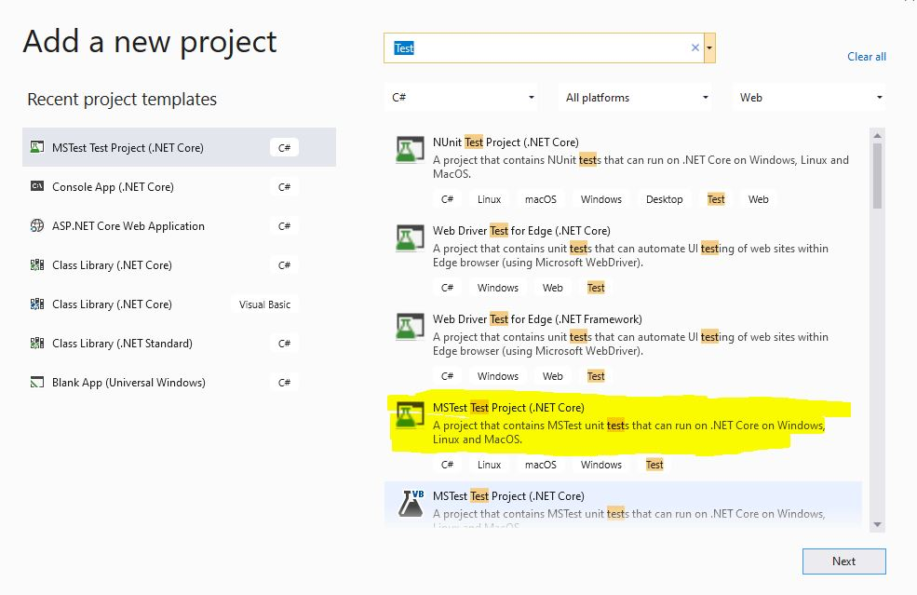

1. Name it your project with “Test” at the end.

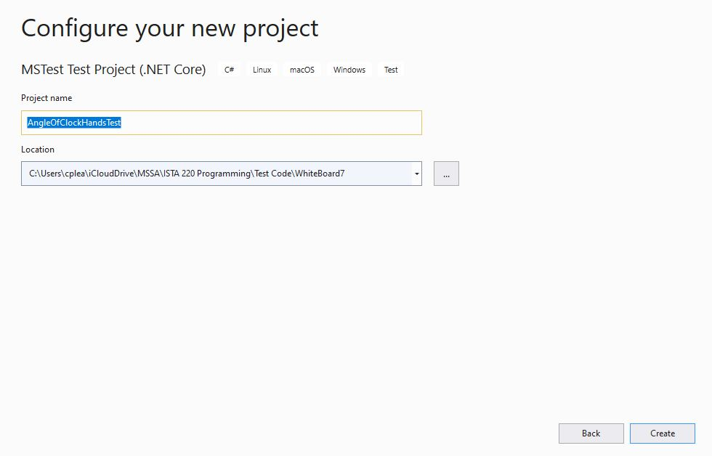

1. Make your original project class public

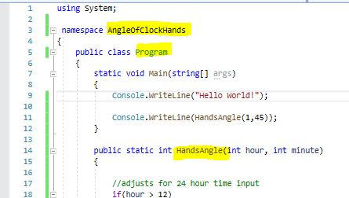

1. Right click the newly created Test Case in the solutions Explorer and add reference to original project

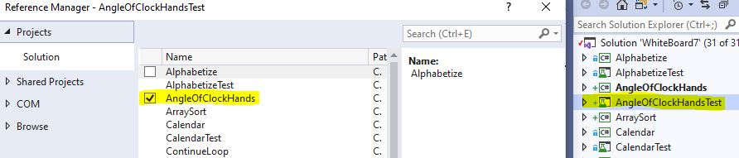

1. Add using statement to the Test Case project, referencing original project.

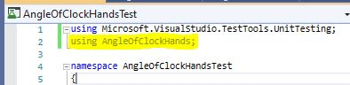

1. Add you test cases to your test file

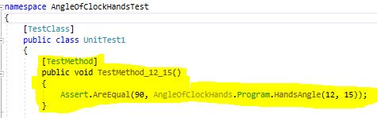

1. Its good to “clean solution” to clear any lingering errors

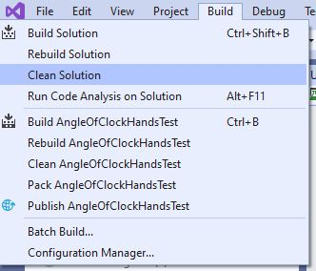

1. Test cases should show up in Test Explorer. Build the test cases(Ctrl + Shift + b )
2. Run the Test cases and cross your fingers

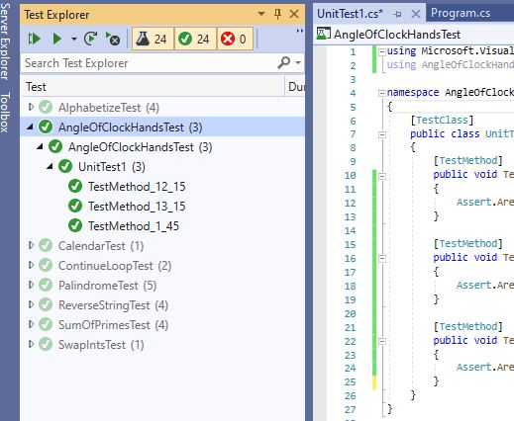

Alternatively right click the specific test and run to not have all tests run every time